Devin Fromond
Lab Report
ECE 2031 L04
11 September 2025

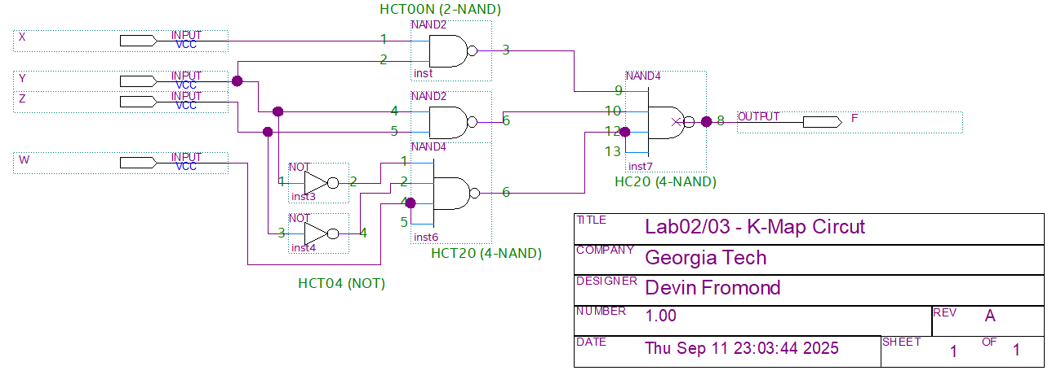
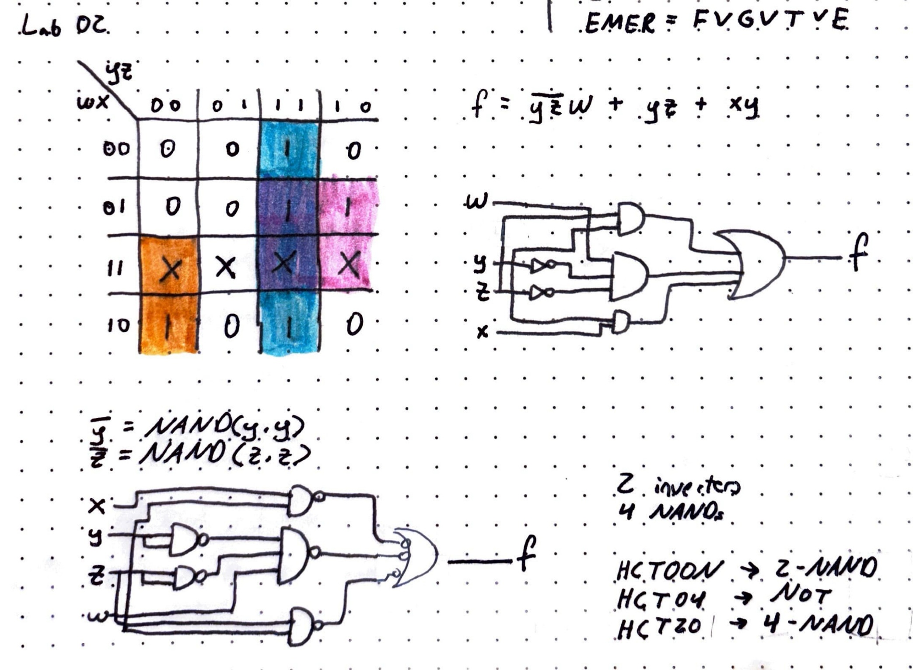
Figure 1. K-Map derived from the Truth Table in Lab 2, to be implemented on a breadboard, forming the expression f = /(y · z) + (y · z) + (x · y).

Figure 2. Schematic for the K-Map (as in Figure 1) comprised of NOT, 2-NAND, and 4-NAND gates with their corresponding pins and device chip labeled.

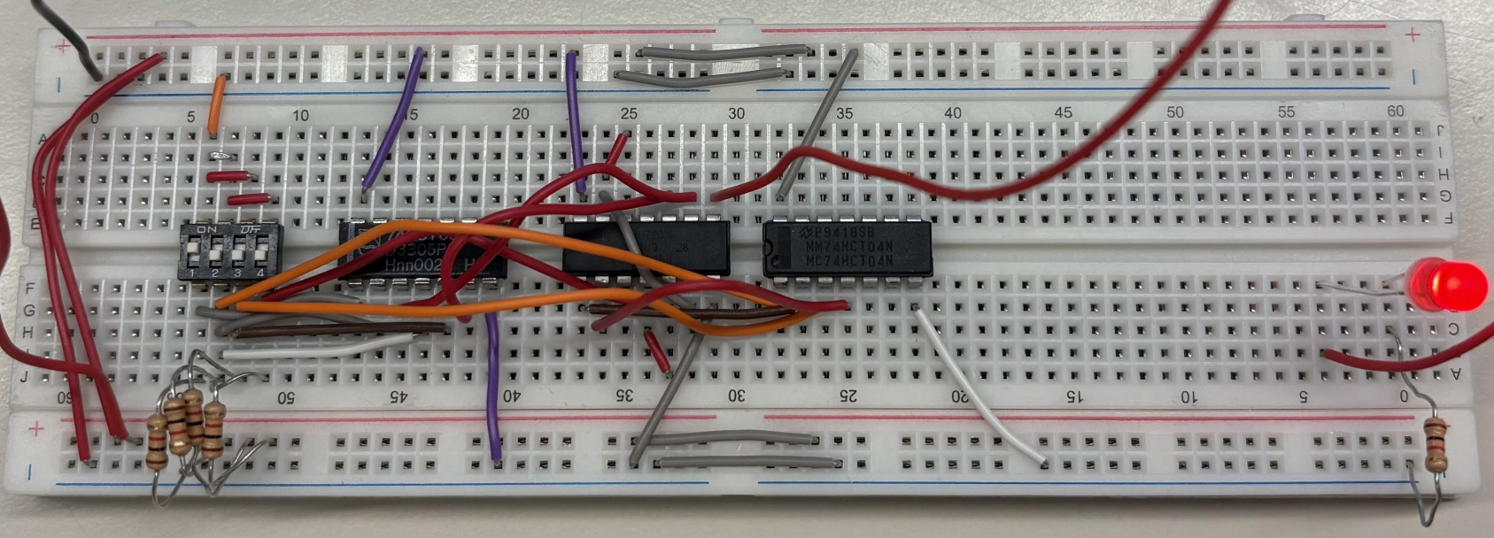
Figure 3. Circuit of the schematic (as in Figure 2) connected to an external power supply, where the output is verified by the LED.

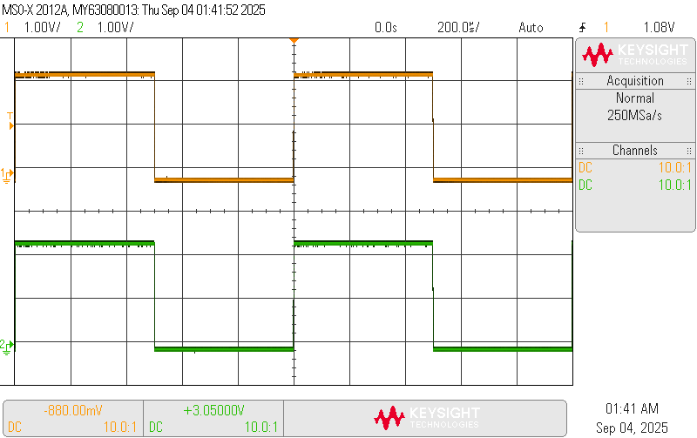
Figure 4. Image of a square wave signal on an oscilloscope screen after scope checkout (validate oscilloscope is working correctly) has been completed.

